# Emergency fund

If you get hospitalized for a few months health insurance will take care of you (if you have), but that wont cover your and your family’s day to day expenses which are not covered by your health insurance.

That’s why you need to maintain emergency fund. Emergency fund is nothing but your family monthly expenses, multiplied by 12 months.

Let’s say if your family monthly expense is 30,000 you need to maintain 3,60,000 in your account.

## Point to note:

You need to adjust this amount by increasing it every year

* according to inflation
* according to increasing expenses (with children coming to family, your expenses are bound to increase)
* just you can check how much is your monthly expense at the December month and multiply it by 12 and see how much of it is the difference between calculated amount and the existing amount

### where to keep the money

three simple rules before you keep your emergency fund in any instrument,

1. The amount you invest should be easily withdrawable in a few days.
2. The amount should not fluctuate or there should not be major loss of capital.
3. The amount should be able to grow almost at an inflation rate

The above 2 points are must and should be followed and the 3rd point is important enough that you should try your best to make it happens

#### Some examples

* Fixed deposit
* Government bonds
* Liquid funds

# Budgeting rule

How to spend your salary, or to retrospect how are you spending your salary

## The 50-30-20 principle

You should be spending 50% for your needs, and 30% for your wants, and 20% for your savings

### Important point

The above proportion is not sacrosanct and can be altered according to one’s needs. But to a better financial life, you need to decrease your needs and wants and increase your savings.

## An important quality

Journalling your expenses gives you a reality about where are you spending your money and also gives you a chance to see how you were spending money and how are you spending money and also compare how your needs, wants and savings changed with your changing salary

# What is your hourly rate and is it increasing?

Your richness depends on your value of time and on how you measure it. If you see your time in days, you will see that you might be earning some thousands of money per day for example 5000 per day and after you spend 5 days of a week working, you just feel like you deserve 2 days of weekend. But if you look at it carefully, that means you are earning 5000 for 8 hours of work. That loosely translates to 600₹ per hour, on weekend you have around 12 hours of free time, that means your one day value on weekend is 7200₹.

Let’s say you use 3 hours of your free time for

* Watching movie with ticket worth 500 and junk food worth 500, what is your day value then
  + 7200 – 600*3 (3 hours spent on movie) – 1000 (spent for tickets and junk) = 5400
* Let’s Say you get back home and start learning a course which is of 3 hours duration and is required at your work which almost no one has full idea over, learning that course makes you a critical resource or a go to person or helps you to increase your net worth.
  + Your current worth 5400 + some learning potential which almost stays with you for life and increases your salary, which in turn increases your hourly rate.
    - I did not calculate the hourly rate because it is almost impossible to value a skill because, it might get more demand or it might get obsolete, but you learning that course will surely increase your learning quotient and adds importance to your experience.

# Where to invest?

* Invest (spending time and money) in yourself by increasing your skills at work
* Invest in gold - only sovereign gold bonds is the best way to invest in gold.
* Invest in schemes by Government: ex- NPS, PPF, SSY
* Bonds – the rate of increase in interest will proportionally increase the risk of loss of capital, if the company defaults, then the money goes to banks and debtors first and there are no chance of return of investment (as mostly they are bankrupt because they don’t have money), unless the owners of the company decide to give some money, there will be hardly any money left for bond buyers
* Fixed deposits – if you are having money which won’t exceed 5 lakhs even after combining principal and Interest received then investing in *small finance bank* (you can also go for public or private banks, but those banks won’t give more interest) is useful because, no matter which bank, their savings account will be secured for 5 lakhs insurance and if the bank defaults, then you can claim that insurance. 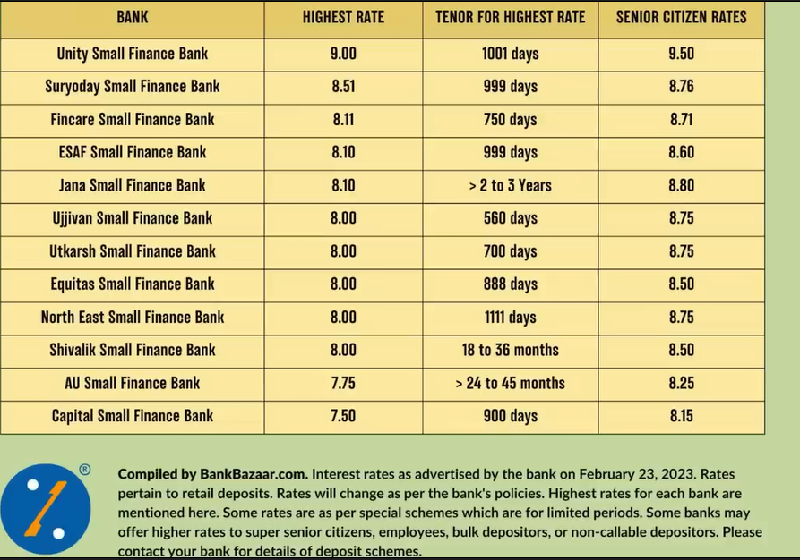
* Mutual funds – you can select direct index funds and in growth mode (don’t go for regular (this will let others eat away your income for no reason) or IDCW option while selecting an index fund (because IDCW will return dividends or wealth periodically) it is not better for long term investment) and do SIP into those funds

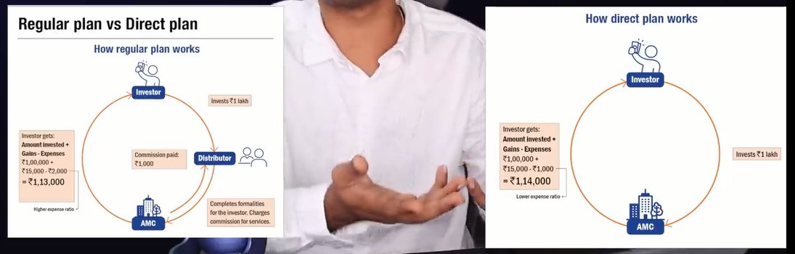

* a

# Be an early bird.

If you start early, you can exponentially increase your corpus (if you invest in a good compounding asset) by the compounding principle.

0.99^365 = 0.02

1.01^365 = 37

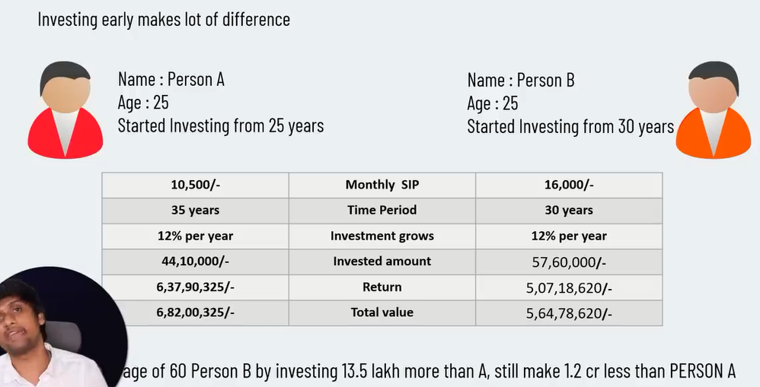

# Bad decisions

* don’t buy gold more than needed.
* Don’t invest in money back plans, because most of the times they return less than 8%
* Don’t invest in market linked plans, instead it is better to invest in index based direct, growth mutual funds
* Don’t take loan on depreciating assets (buying car, buying jewellery), instead take loan on appreciating assets (taking education loan, home loan, business loan (with conviction that you will surely earn more than interest rate))